Install and configure the Warehousing app

https://docs.microsoft.com/en-us/dynamics365/supply-chain/warehousing/install-configure-warehousing-app
Platform | Version
Android | 4.4, 5.0, 6.0, 7.0, 8.0, 9.0
Windows (UWP) | Windows 10 (all versions)
Finance and Operations | Microsoft Dynamics 365 for Operations, version 1611  -or-  Microsoft Dynamics AX version 7.0/7.0.1 and Microsoft Dynamics AX platform update 2 with hotfix KB 3210014

Get the app on y our phone or tablet
- Windows (UWP)
  - Finance and Operations - Warehousing on the Windows Store
- Android
  - Finance and Operations - Warehousing on the Google Play Store

Go to your Azure Portal
https://portal.azure.com
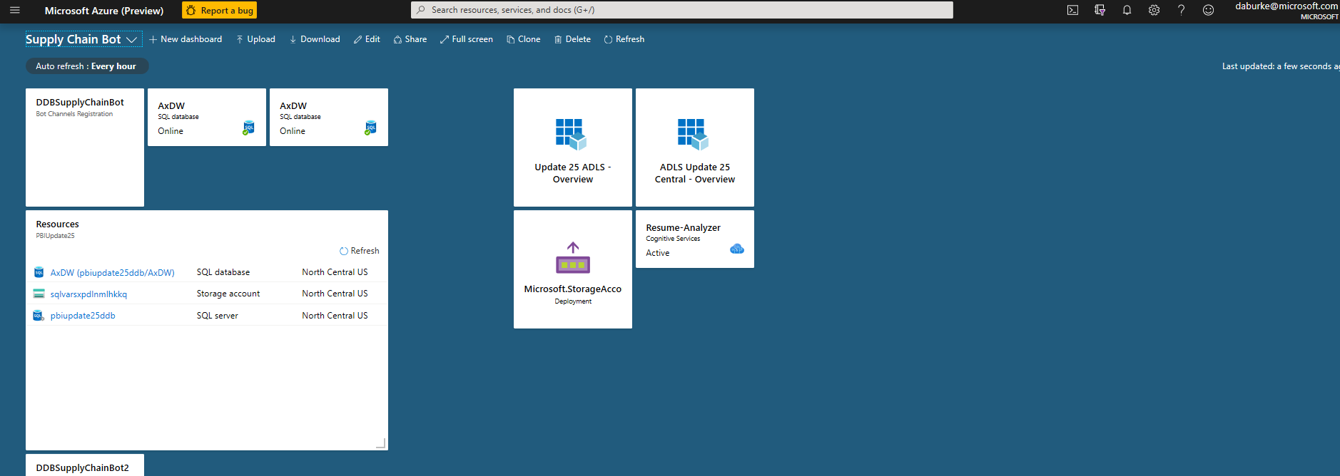
Got to Azure Active Directory
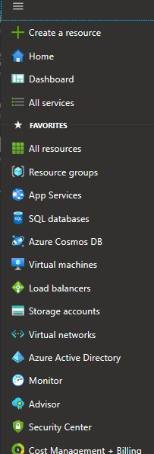
Go to App Registrations
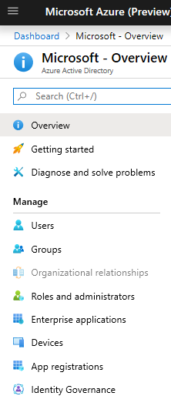
Click on +New Registration
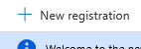
Add a Name
Click “Accounts in this organizational directory only (Microsoft only – Single Tenant)”
Click Register

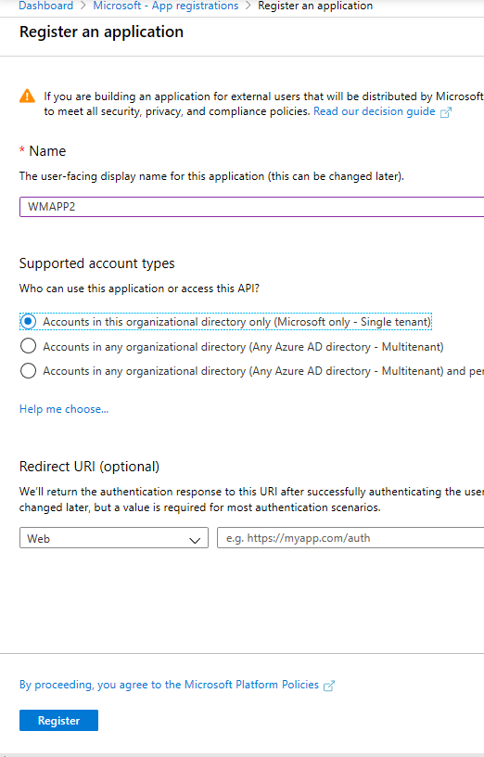

Copy Down the Application (client) ID

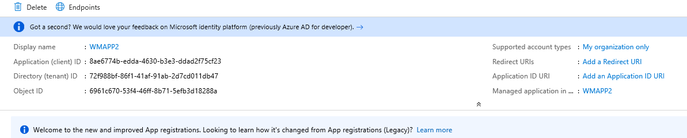
Display name
:
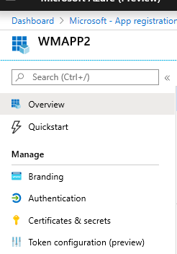
Click on +New client secret
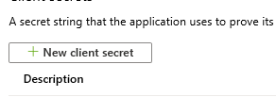
Give the secret a name and expiration
Click “Add”
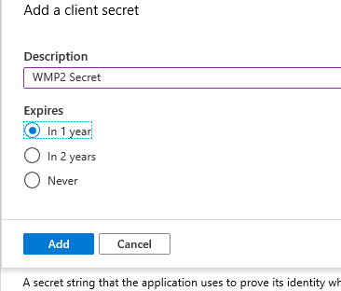

Copy the value down. It will disappear after you leave the page.

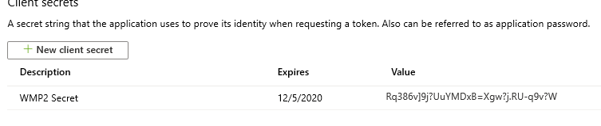
Go back to Overview
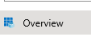
Click on Endpoints

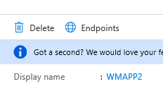
Copy the OAuth 2.0 authorization endpoint (v2)
https://login.microsoftonline.com/72f988bf-86f1-41af-91ab-2d7cd011db47/oauth2/v2.0/authorize
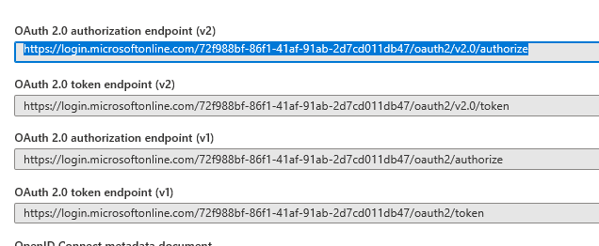

Go into Finance and Supply Chain to create a new user
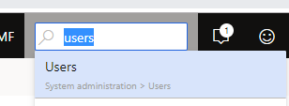
New User
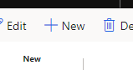
Add Usuer “WMAPP
Assign Warehouse mobile device user

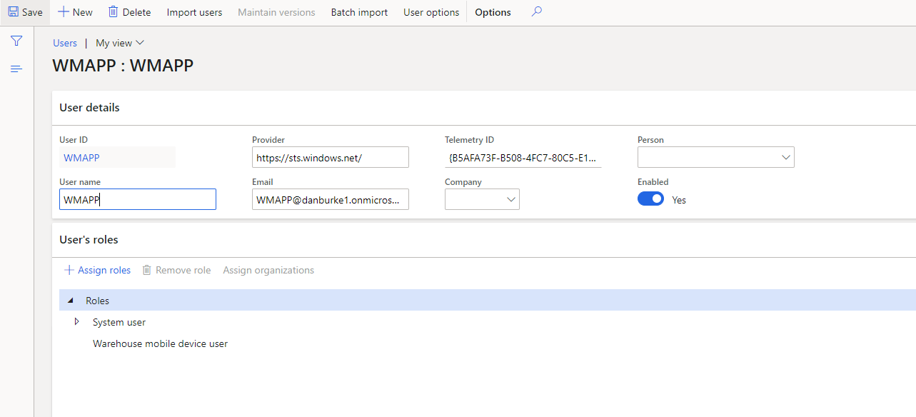

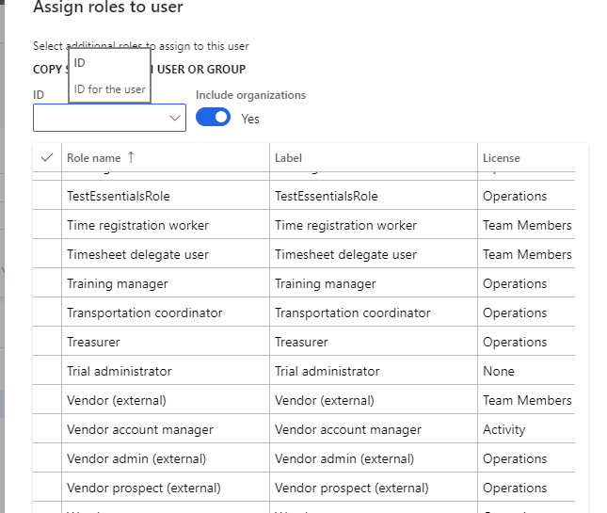

go to System 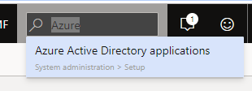administration > Setup > Azure Active Directory applications.

Add a line with your new client ID number
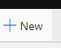

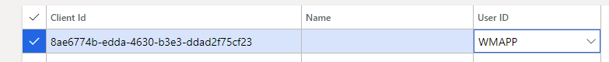

Configure the App on your phone or tablet

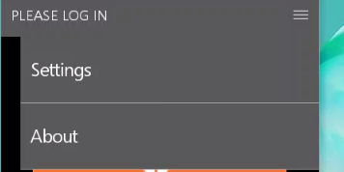

Copy in the Active Directory Client ID (the same on you entered in FnO)
Copy in the Client Secret
Copy in the Active Directory Resource (your URL for your instance)
And copy in the Active Directory Tenant – This is your endpoint you copied
Lastly, enter the company you will be using

